Introduction:

Before COVID-19 pandemic struck, a professional run business restaurant was established, called Prime Steakhouse & Bar at JW Marriott, Putri Hijau Road, in Medan, North Sumatra, Indonesia. It is dealing with steak, ribs, pasta and beverages. We serve our customers for take-away and dine in. Teenagers are the target of our business because we provide food that suitable for people with young ages or for couples. Besides, we also have a special private room with the capacity of 20 persons in which it is our service for companies that want to have a meeting in our restaurant. We provide romantic and cosy environment in our fancy restaurant. We set an excited western song to accompany our guests while they are enjoying our dish in Prime Steakhouse & Bar. This is the excellent venue for intimate romantic dinner, exclusive meeting or casual gathering among friends, as well as for larger celebrations.

**Current System :**

Everything was looking good until this pandemic nightmare attacked Indonesia. We have lost 90% of our dine in customers. Moreover, we can’t really rely on our deliver partner only to survive, such as Grab Food, Go Food, etc due to high delivery fee they charge to our customers furthermore we also get charged by them. This makes our profit even lower meanwhile we need to give discount to attract our customers in order to make them interested in purchasing our food. Actually, we have our own social media such as, Instagram, Twitter, and Facebook. However, after few months have passed, we believe we can’t just depend on them because our sale volume doesn’t increase much. We are ever, thinking of laying off few of our employees that one may decrease our cost. On the other hand, we can’t do this. Thus, we decide to create our own website. So, our customers will gain information and updates about our restaurant. Hopefully, this shall expand our income in the future. Therefore, we don’t need to cut off few of our employees.

**Objective :**

Due to the social distancing situation, to decrease interaction between our employees and our customers who dine in, we have changed our menu and an order form from paper to paperless. Which means when our customers dine in, we just hand our tablet to them and they can just order from our website that already in the tablet. Else, our customers will be able to order our product from our website first before they visit Prime Steakhouse. Then, our customers just need to give their name to our staff. Next, they just sit down and enjoy soothing fancy and romantic atmosphere of our restaurant while waiting for our employees preparing their dish.

Another purpose of creating our own website is to maintain or increase our sales volume through our own delivery team and to cut cost as well as delivery time. In order to provide customer satisfaction, this website also serves take-away order by visiting our website directly and pay over OVO and credit card, etc. Hence, we not really depend on this online food and delivery partner.

Storyboard :

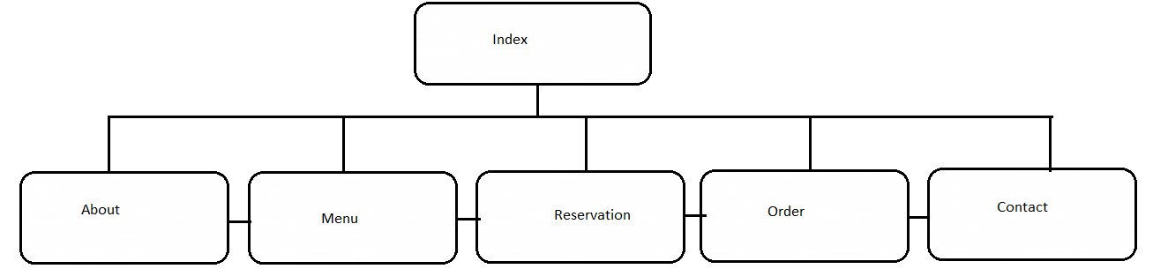

Index.html

This webpage provides some information about our delivery service for takeaway guests as well as upcoming event date.

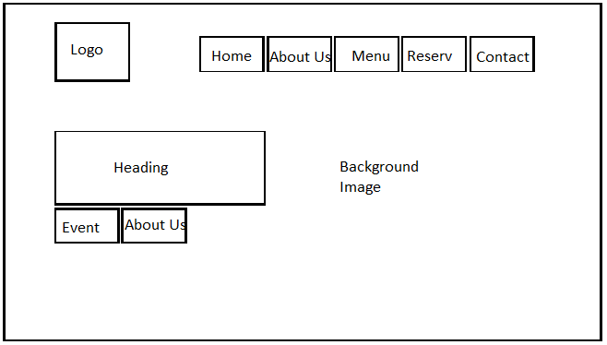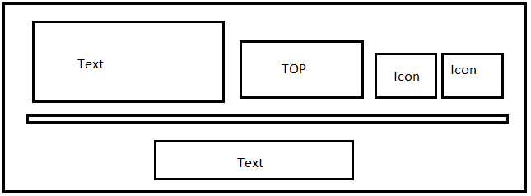

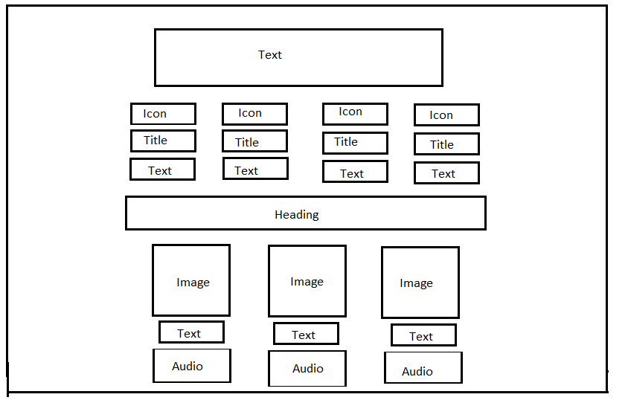

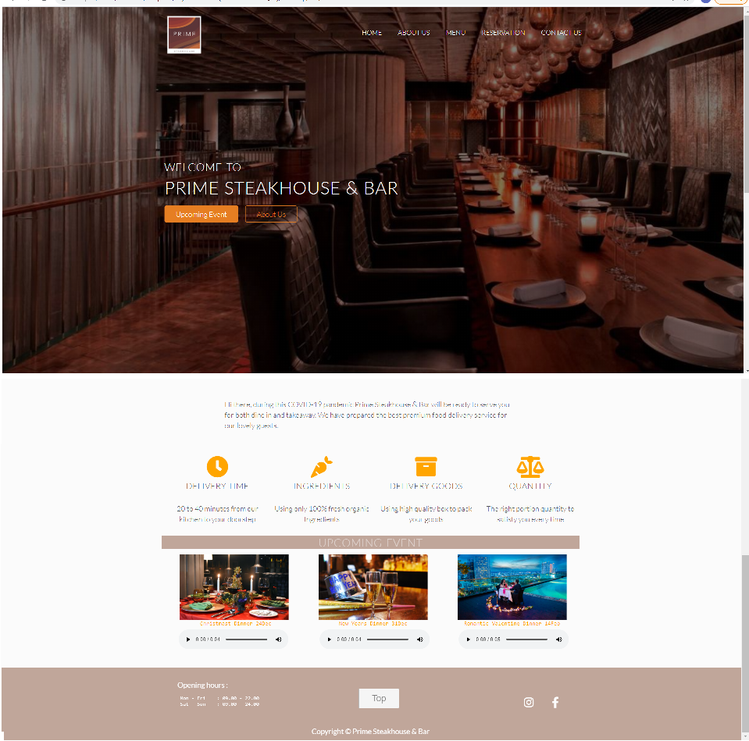

AboutUs.html

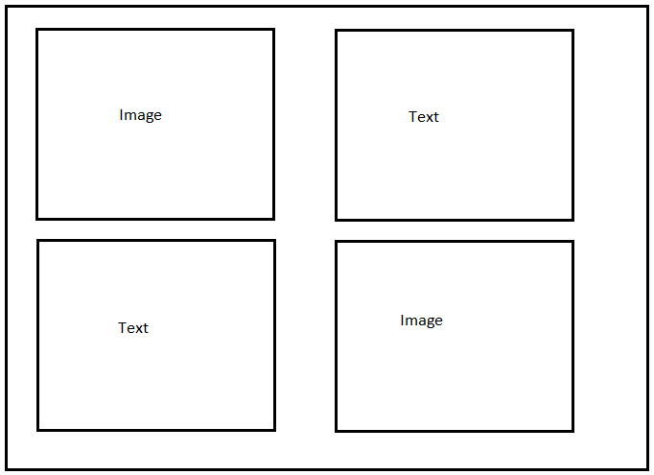This webpage tells our restaurant’s guest about our history and our ingredient.

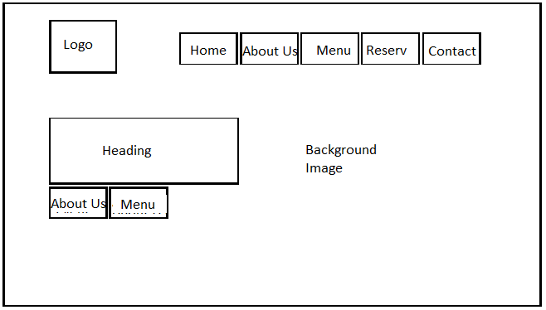

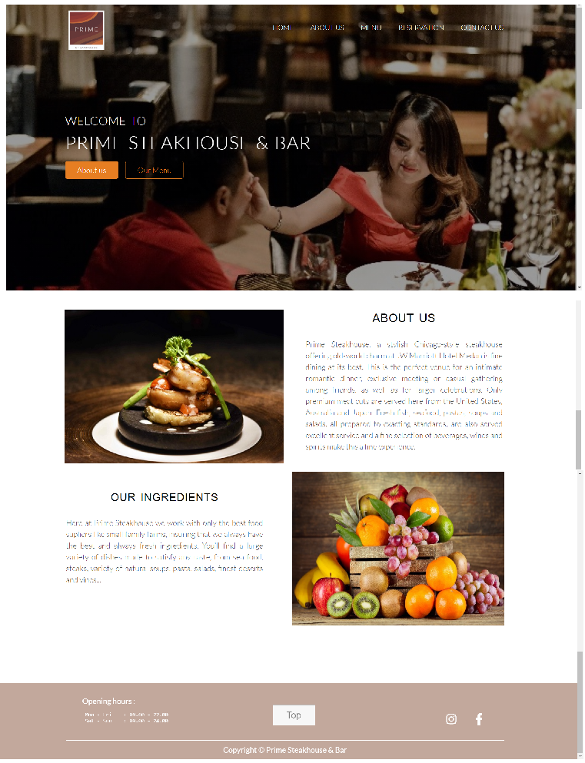

Menu.html

This page provides all of our menu and also our special menu with its price

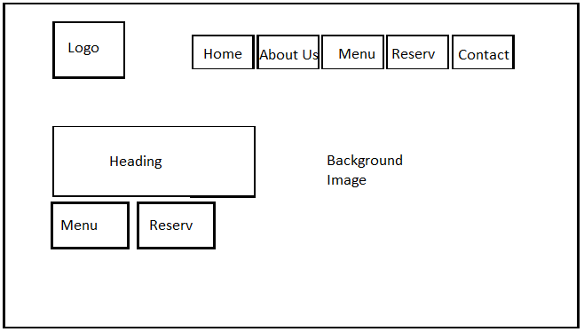

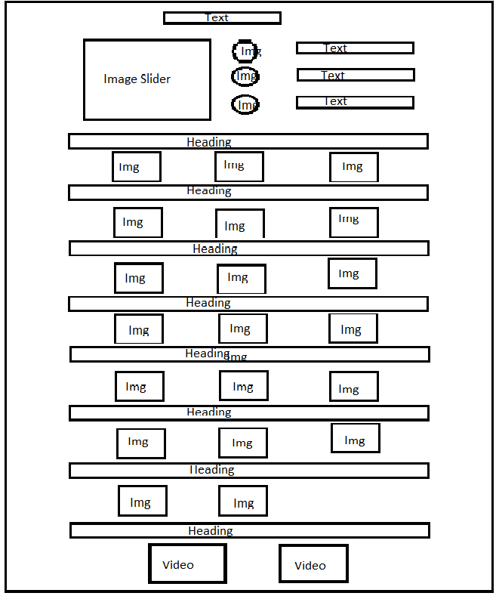



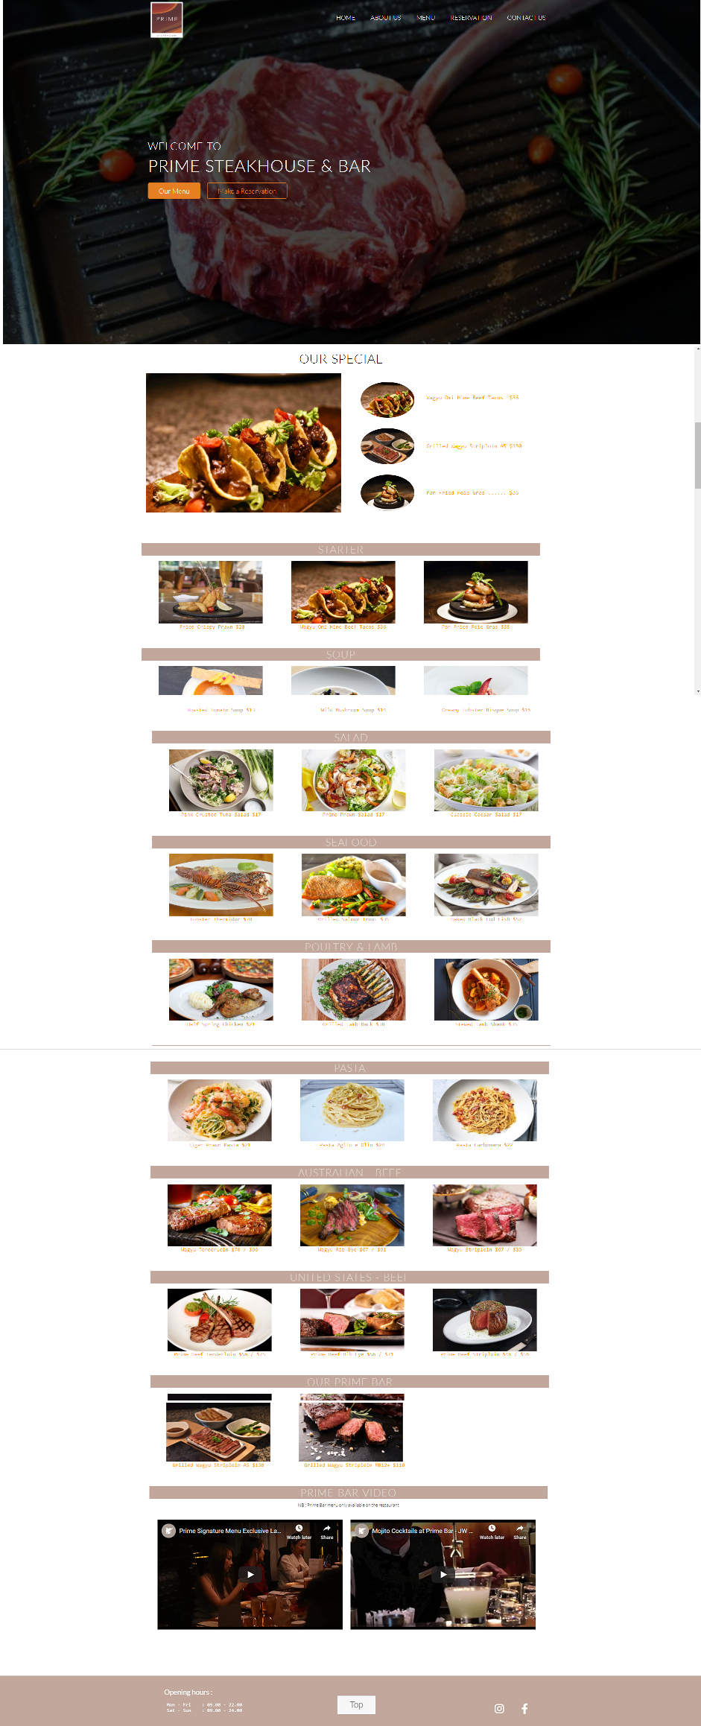

Reservation.html

To minimize conversation between our guests and our employees, we design this page for them to order online before they visit our restaurant.

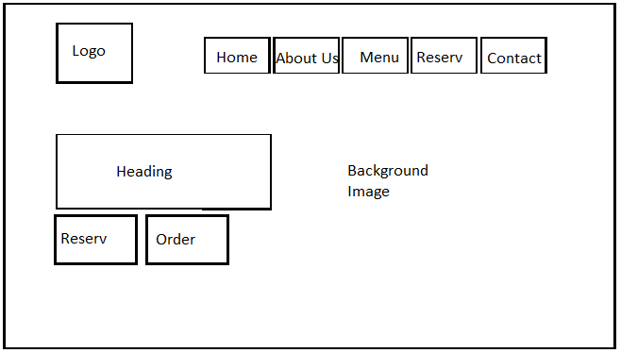

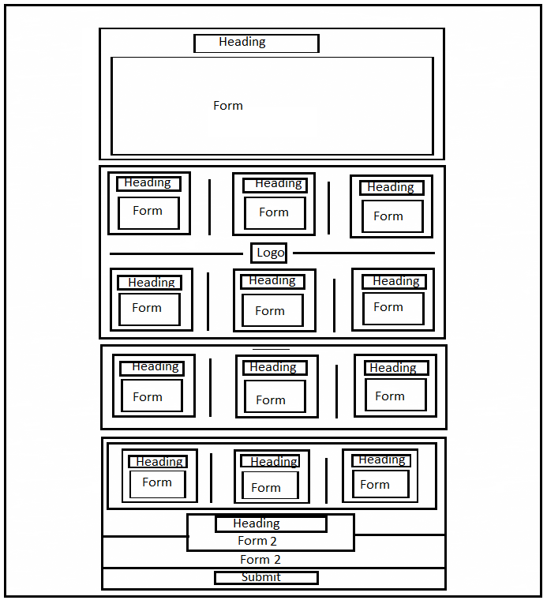

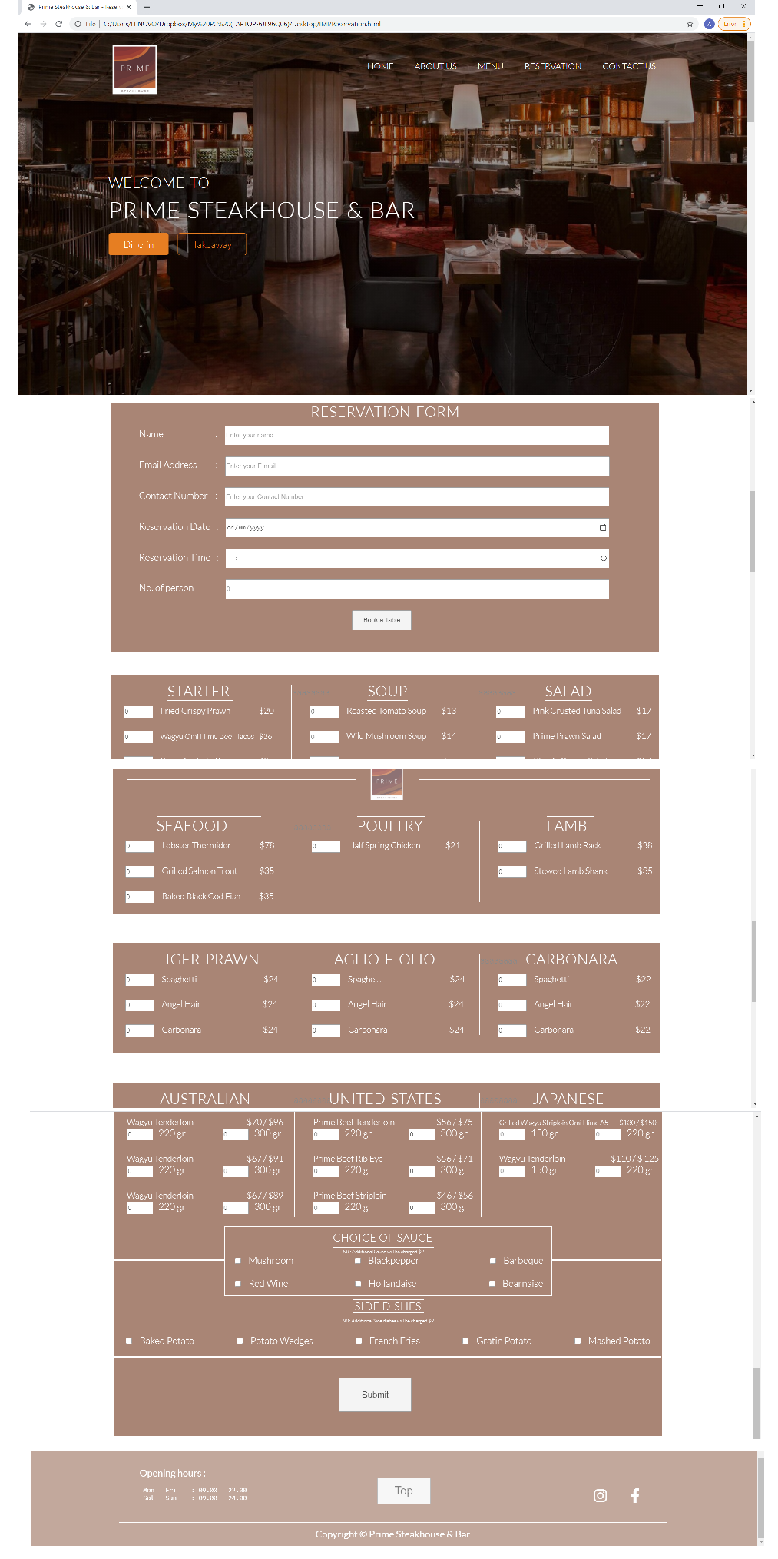

Order.html

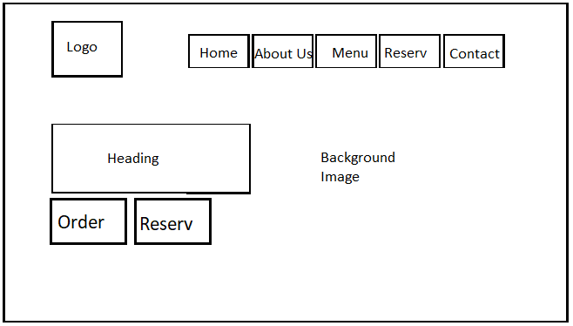This web page is created for those people who wants to dine in at our restaurant. However, get scared of getting out during this pandemic

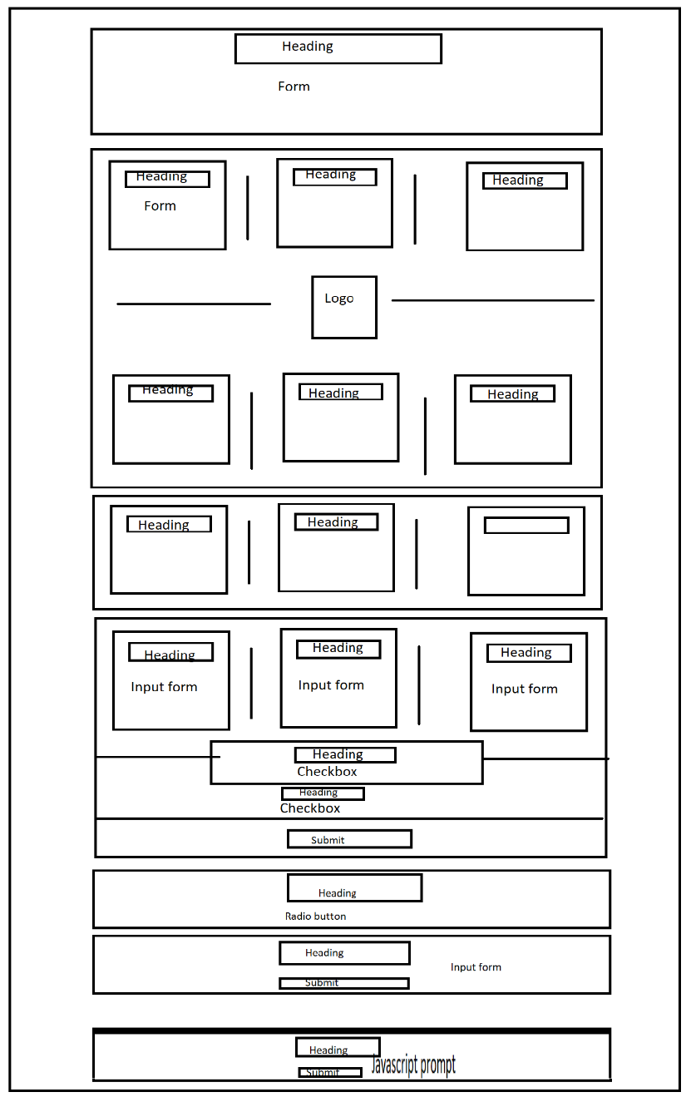

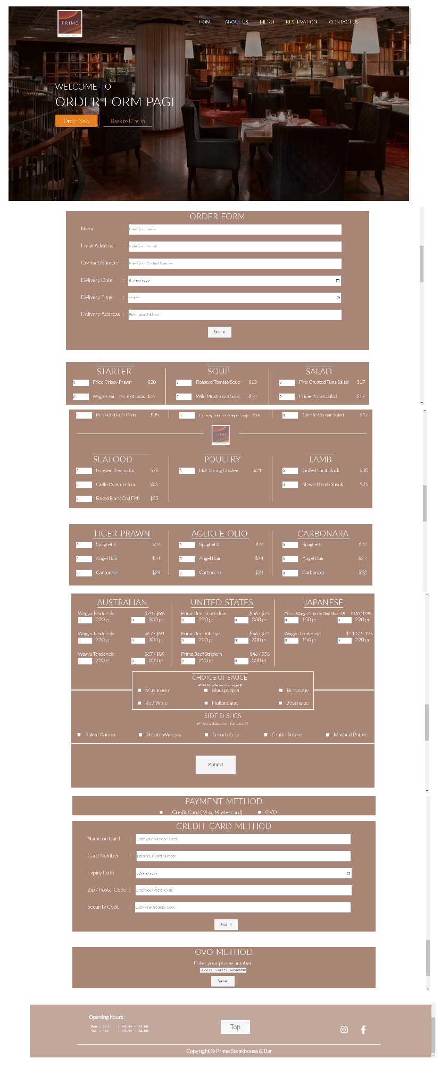

Contact.html

This page is useful for them who want to know further information about us and there is our contact number for them who want to contact us.

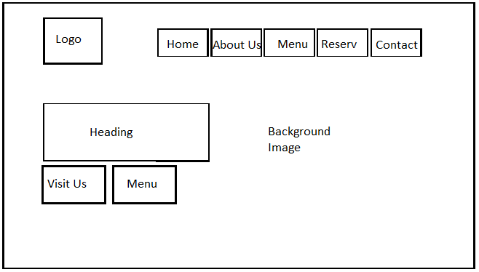

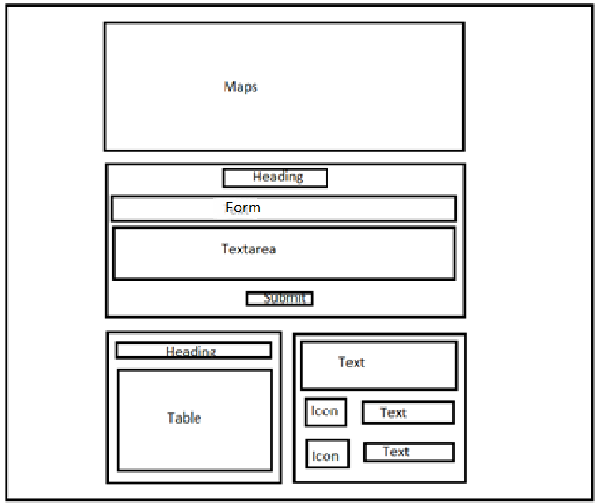



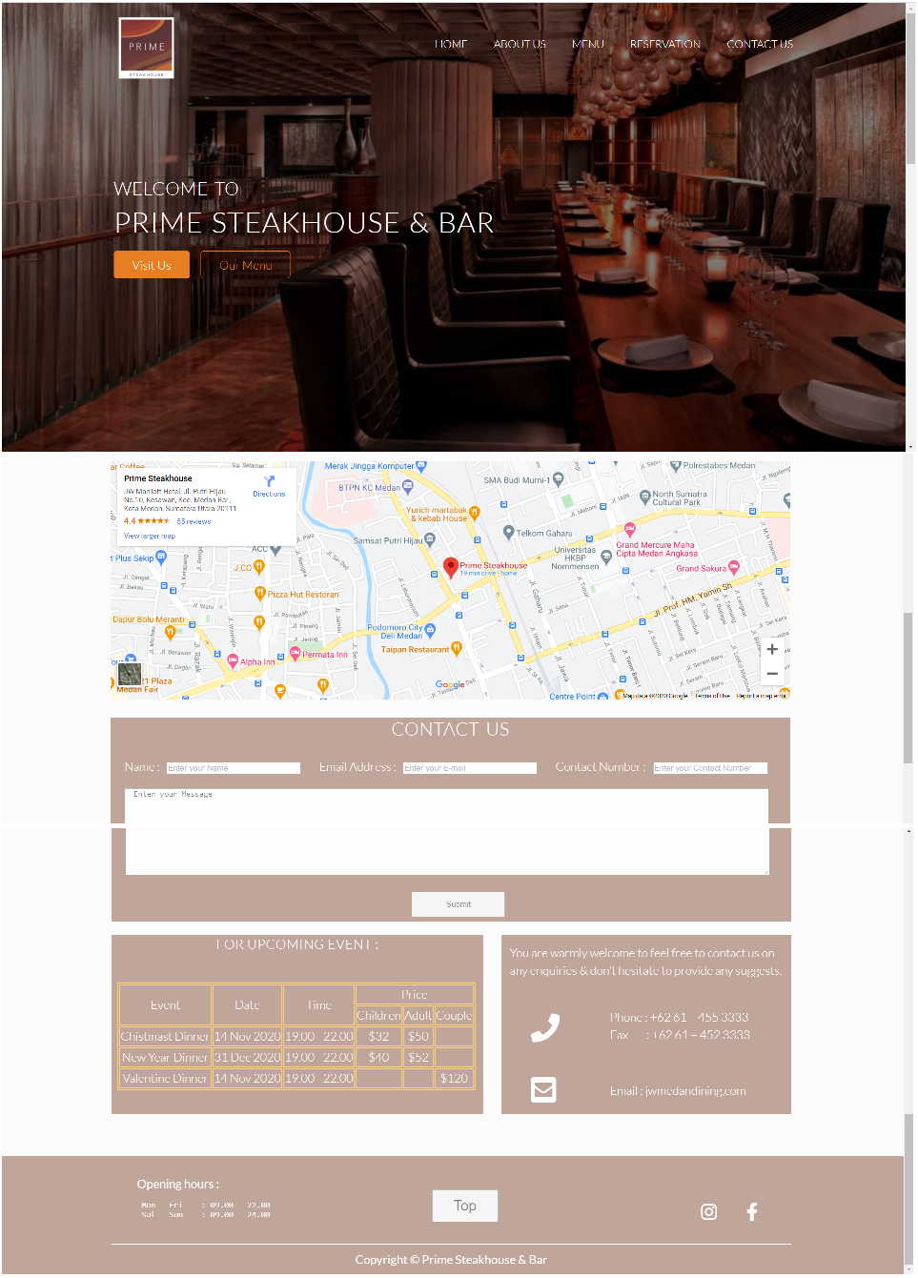

Reference:

1. W3schools. (n.d). *How TO-Slideshow*. [slideshow]. Retrieved from (<https://www.w3schools.com/howto/tryit.asp?filename=tryhow_js_slideshow_auto>)
2. W3schools. (n.d). *How TO-Slideshow*. [Button]. Retrieved from

(<https://www.w3schools.com/howto/howto_js_scroll_to_top.asp>)

1. W3schools. (n.d). *Window prompt () Method*. [Prompt]. Retrieved from

(<https://www.w3schools.com/jsref/met_win_prompt.asp>)

1. W3schools. (n.d). *Window alert () Method*. [Alert]. Retrieved from (<https://www.w3schools.com/jsref/met_win_alert.asp>)
2. Sovy. (2012). *Merry Christmas and a happy new year.mp3*. [Audio]. (<https://freesound.org/people/sovy/sounds/172303/>)
3. Gabovitch, Iwan. (2014). *Cute Happy Valentines Day Voice*. [Audio].

(<https://freesound.org/people/qubodup/sounds/218175/>)

1. JW Marriott Medan. (2018). *Prime Signature Menu Exclusive Lunch*. [Video].

(<https://www.youtube.com/results?search_query=mw+marriott+prime+steakhouse>)

1. JW Marriott Medan. (2016). *Mojito Cocktails at Prime Bar – JW Marriott Medan*. [Video].

(<https://www.youtube.com/results?search_query=mw+marriott+prime+steakhouse>)

1. Font Awesome. (n.d). *Font Awesome Icons*. [Icons]. (<https://fontawesome.com/icons?d=gallery>)
2. Google Fonts. (n.d). *Google Fonts Family*. [Font]. (<https://fonts.google.com/?vfonly=true>)
3. 0to255. (n.d). 0to255: *Color Picker Tool*. [Color]. (https://www.0to255.com/)
4. JW Marriott Medan Dining. (n.d). *Promotions – Page4 – JW Marriott Medan Dining*. [Images]. (https://jwmedandining.com/en/promotions/4/)
5. NYT Cooking – The New York Times. (n.d). *Food* *Recipes*. [Images]. ([https://cooking.nytimes.com/recipes/](https://cooking.nytimes.com/recipes/1014475-wild-mushroom-soup))
6. WallpaperSafari. (n.d). *Fruit Wallpaper HD*. [Image]. (<https://wallpapersafari.com/w/az1dN0>)
7. TheFoodExplorers. (n.d). *Top 50 Best Grilled Prawn Salad Recipes on The Net.* [Images]. (<http://thefoodexplorer.com/salad/best-50-grilled-prawn-salad-recipes-on-the-net/>)
8. Jee, Lynn. (2018). Classic Caesar Salad with Crispy Anchovy. [Image]. (<https://myfishman.com/blogs/recipes/classic-caesar-salad-with-crispy-anchovy>)
9. 123RF. (n.d). Grilled Salmon trout fillet with potato-spinach mash and vegetables Indoors closeup. [Image]. (<https://www.123rf.com/photo_30880860_grilled-salmon-trout-fillet-with-potato-spinach-mash-and-vegetables-indoors-closeup.html>)
10. Chatelaine. (n.d). Roasted black cod with tomatoes. [Image]. (<https://www.chatelaine.com/recipe/dinner/roasted-black-cod-with-tomatoes/>)
11. TripAdvisor. (n.d). Lobster Thermidor. [Images]. (<https://www.tripadvisor.com/LocationPhotoDirectLink-g297895-d3858963-i224898949-Fine_Dining_by_Saman_Villas-Bentota_Galle_District_Southern_Province.html>)
12. Saveur. (2019). Grilled Rack Lamb with Garlic and Herbs. [Image]. (<https://www.saveur.com/grilled-rack-lamb-with-garlic-and-herbs-recipe/>)
13. Healthier. (n.d). Lamb Shank Casserole. [Image]. (<https://www.healthier.qld.gov.au/food/recipes/lamb-shank-casserole/>)
14. MishimaReserve. (n.d). Wagyu Rib Eye. [Image]. (https://www.mishimareserve.com/ultra-eye-of-ribeye)

THANK YOU SIR